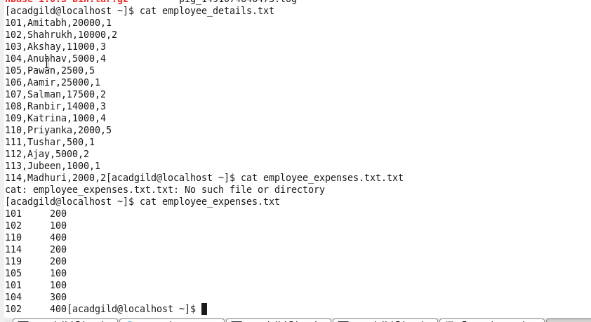

Creating pig relation emp_details for employee_details in local mode

**Pig -x local**

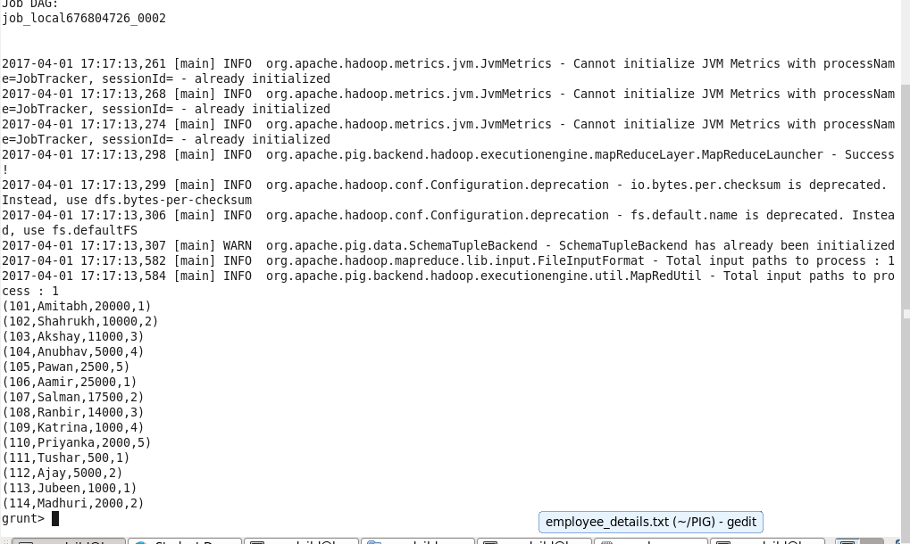

Created pig relation for employee_expenses.txt

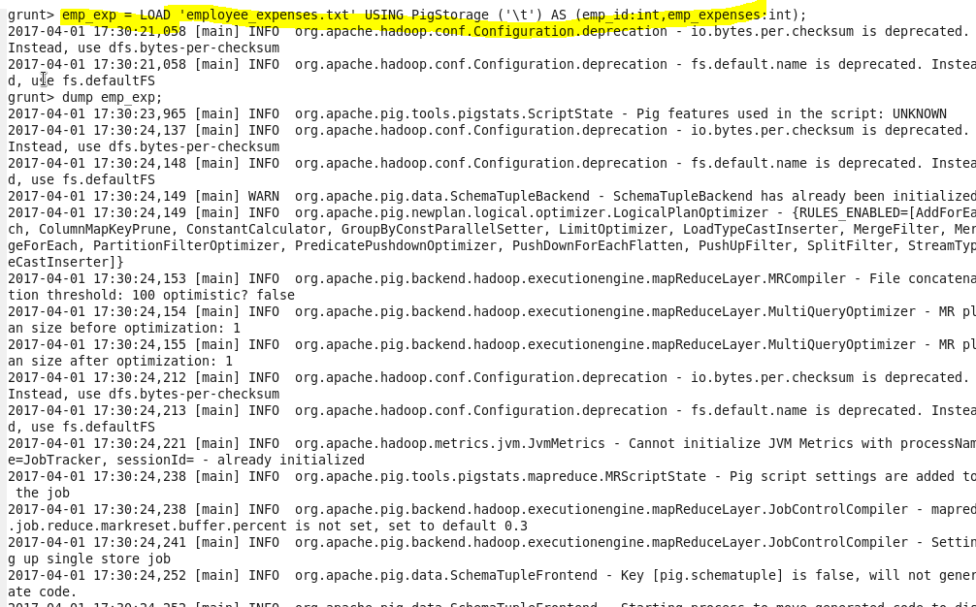

# (a)Top 5 employees (employee id and employee name) with highest rating. (In case two employees have same rating, employee with name coming first in dictionary should get preference)

Emp_details

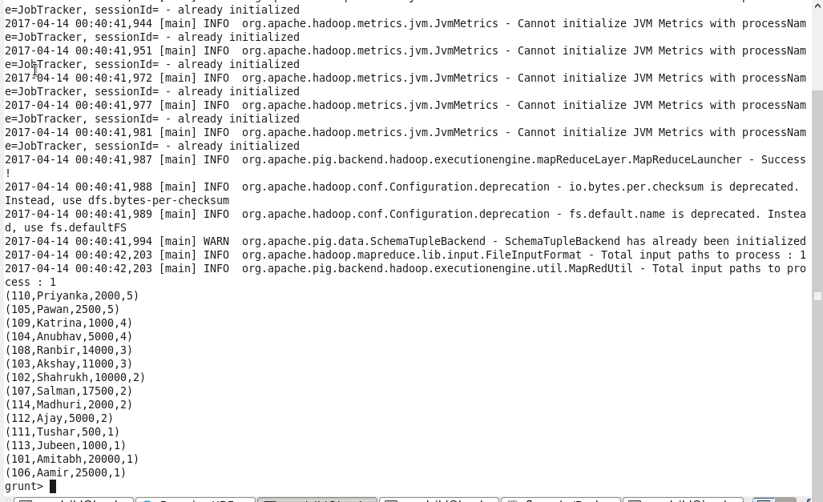

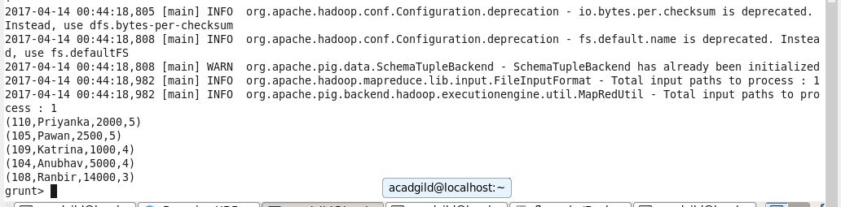

# (b) Top 3 employees (employee id and employee name) with highest salary, whose employee id is an odd number. (In case two employees have same salary, employee with name coming first in dictionary should get preference)

Employee with highest salary and odd id no

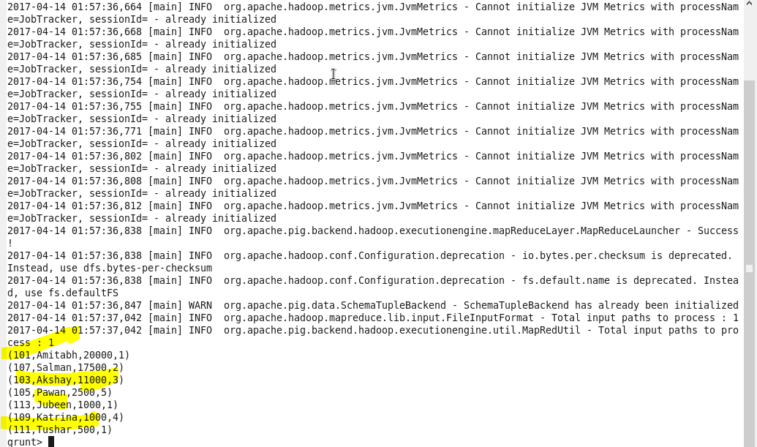

**Using limit command to get only 3 records**

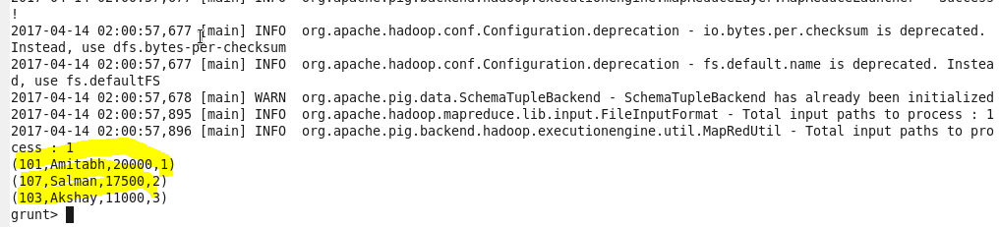

# (c) Employee (employee id and employee name) with maximum expense (In case two employees have same expense, employee with name coming first in dictionary should get preference)

Loading employee_expenses in pig

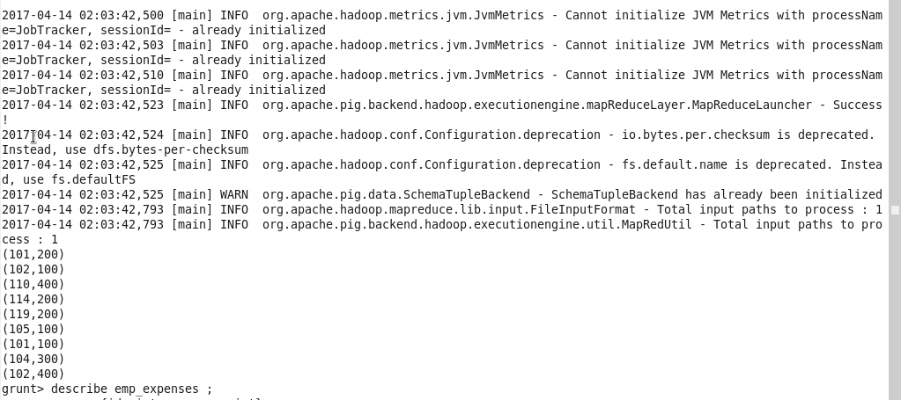

Joining emp_details by id and emp_expenses by id;

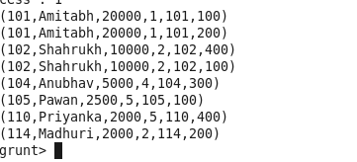

Using order by command to get the salary

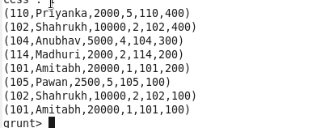

USING GROUP COMMAND



Filtering id, name and expenses



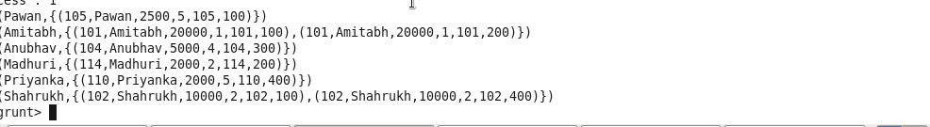

# (d) List of employees (employee id and employee name) having entries in employee_expenses file.

Used inner join to find the list of employees having entry in expenses table

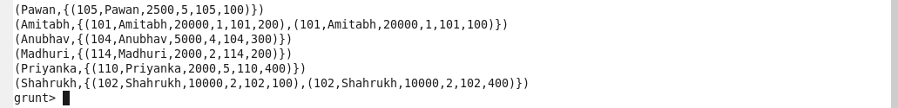

# (e) List of employees (employee id and employee name) having no entry in employee_expenses file.

Finding the cogroup data

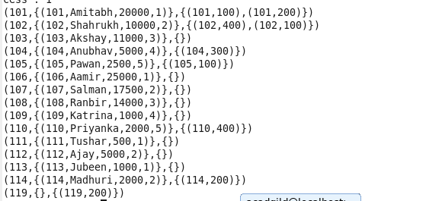

Now performing the diff command



Records in yellow are the employee which are having no entry in emp_expenses table

